***Directions: Provide a snippet of each figure in the tutorials below.***

**Tutorial 10-1 (Pg. 637):**

1. Figure 10-16:

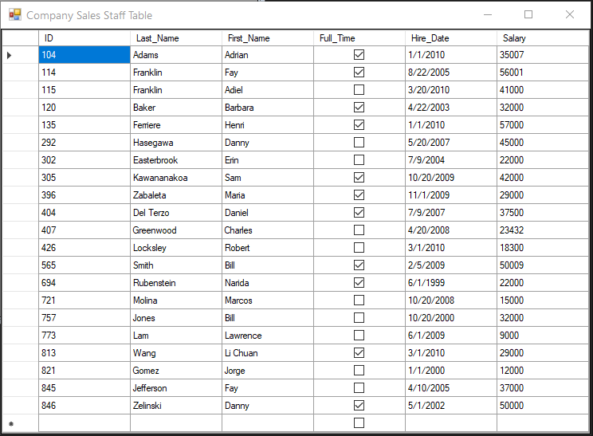

**Tutorial 10-2 (pg. 645):**

1. Figure 10-19:

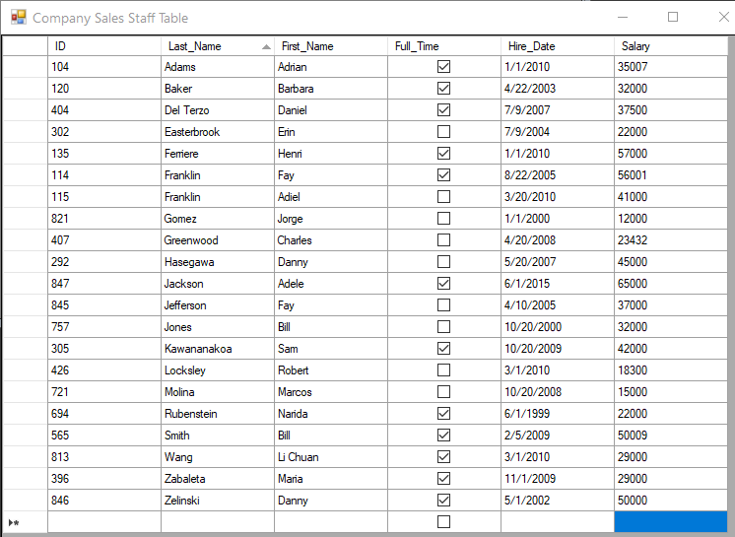

**Tutorial 10-3 (pg. 653):**

1. Figure 10-31:

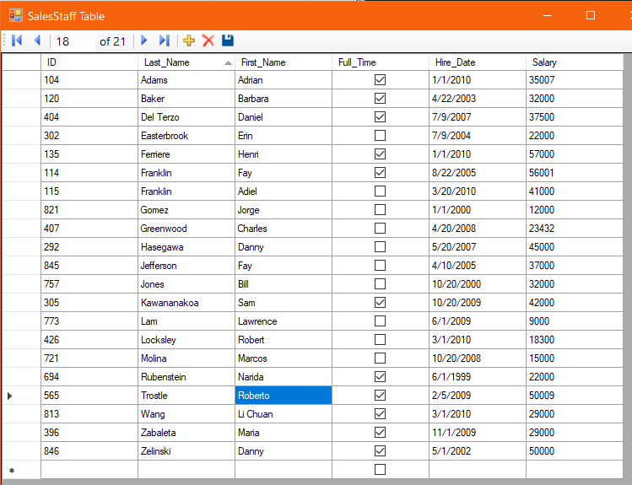

***Continuation of Snippets:***

**Tutorial 10-4 (pg. 655):**

1. Figure 10-35:

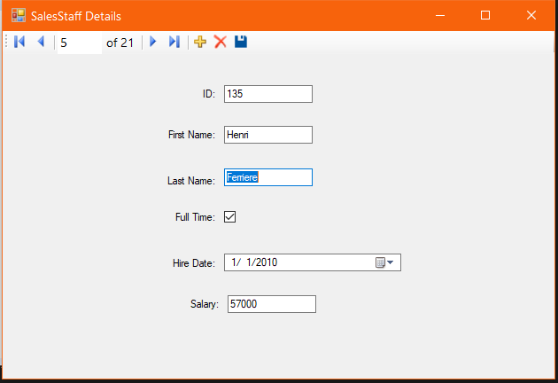

**Tutorial 10-5 (pg. 659):**

1. Figure 10-41:

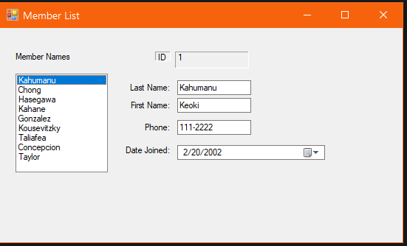

**Tutorial 10-6 (pg. 662):**

1. Show Error Message After Step 18:

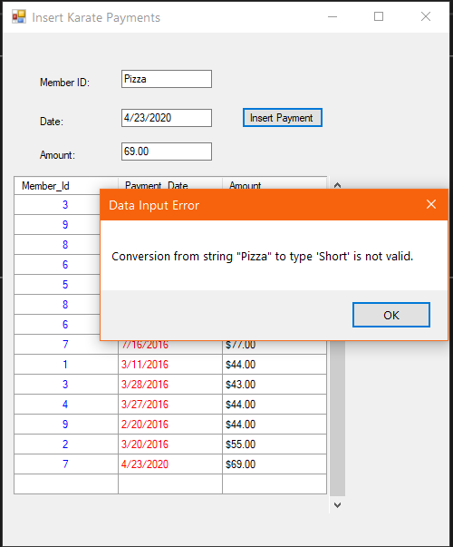

**Tutorial 10-7 (pg. 666):**

1. Figure 10-46:

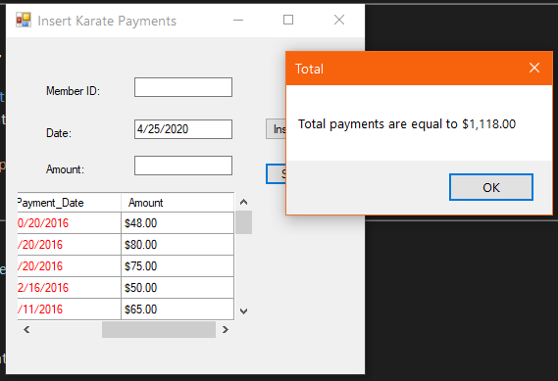

**Tutorial 10-9 + 10-10 (Starting on pg. 680):**

1. Figure 10-57:

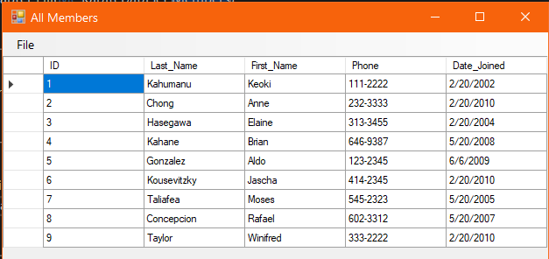

**Tutorial 10-11 (pg. 684):**

1. Provide a snippet of the Error Message:

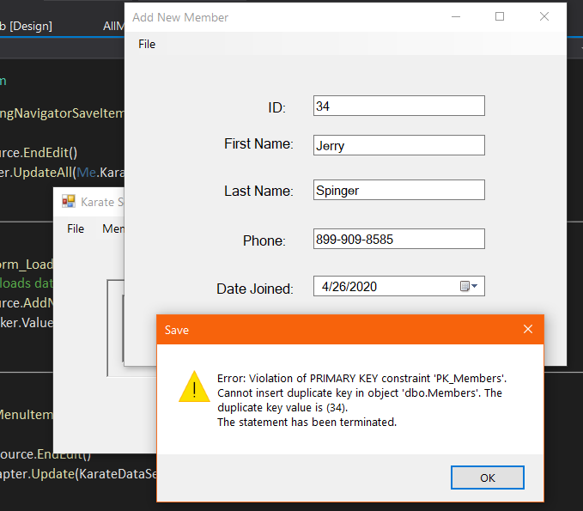

**Tutorial 10-12 + 10-13 (Starting on pg. 686):**

1. Figure 10-69:

